Small Business Incentive Program
Guidelines & Application

Small Business Incentive Program
An Economic Development Program

About the Program
The City of Champaign is offering their Small Business Incentive Program as a matching award program targeted to local entrepreneurs. The purpose of the award program is to assist businesses with obtaining professional services in the areas of business advice, legal, financial/bookkeeping, and marketing assistance. The program also includes an education credit to be used by the entrepreneur to expand his or her knowledge base and certifications needed to start and grow the business. The program works by prequalifying a series of professional service providers that have offered packages of assistance at set prices to make it easier for entrepreneurs to seek their advice. The Planning and Development Department will maintain a list of providers. Any provider may be added to the list if they are able to provide the services outlined in the scope of services below. Applicants will apply to the program after initial consultation with our program partner, the Illinois Small Business Development Center at Champaign County EDC. Once approved, applicants may schedule appointments with providers of their choice from the list of pre-qualified providers. With City approval applicants may also add providers they have a current relationship with to the list. The City will then cover a percentage of the cost of that service.

Eligible Applicants
- Applicants must be registered clients of the Illinois Small Business Development Center at Champaign County EDC. The SBDC offers business counseling services at no charge, and clients can register on the SBDC website at www.cusbdc.org.
- Applicants may receive counseling from other entities provided they meet the eligibility criteria outlined in this application.
- Applicants must have completed the workshop “Starting Your Small Business” offered monthly by the SBDC. The SBDC Director may override this requirement in individual cases.
- Applicants must be operating legally in accordance with all federal, state and local laws and regulations and be current with all city taxes, fees and licenses.
- Applicants must open their business within the corporate limits of the City of Champaign.
- Applicants must submit a business plan that follows the outline provided.

Note: Adult oriented businesses (Champaign City Code Article VII, Sec 5-101) are not eligible for this program.

Applicants will have one (1) year from the date of approval to complete the program.

Eligible Services
The chart below indicates the services that this program covers. Applicants will be able to choose which services they need to work directly with a pre-approved provider to perform these services. Other business-related services within these areas may be authorized by the SBDC Director and the City. Applicants must detail the benefit that selected services will have on their business or the wider community in the case of non-profits, in the Use of Funds section of the Business Plan. For example, increased profit, additional jobs or meeting another business goal. Applicants must identify clear deliverables for marketing services.

Service Types | Small Business Development Center  Assistance | Marketing  Package | Legal Services  Package | Financial and Payroll Services  Package | Educational Credit
Scope of Services | - Business consultation  - Business plan assistance  - International trade assistance  - Small business workshops  - Liaison with Small Business Administration  - Liaison with Illinois Department of Commerce  - Assist with market research | - Initial website consultation  - Initial logo design  - Social media, Adwords setup  - Framework for beginning an ad campaign | - Initial company formation and bylaws,  - State and Federal filings (filing fees paid by entrepreneur)  - Employment agreement  - Non-disclosure/non-compete agreements  - Office space lease  - Copyright and trademark protection | - Initial counseling session  - Payroll admin and tax withholding  - Quarterly and annual financial statements  - Assistance with bookkeeping software setup  - One Year subscription of bookkeeping software  - Point of Sale technical assistance | - Licensing and permitting programs  - Continuing education classes  - Business workshops

Professional Service Providers
Applicants may choose a provider of their choice given that they are able to meet the scope of work indicated above and meet the following criteria:
- Provider must operate a business within Champaign County.
- Provider must comply with the City of Champaign Equal Opportunity and Purchasing Ordinance.
- Provider must be operating legally in accordance with all federal, state and local laws and regulations and be current with all city taxes, fees and licenses. Applicants may not select a provider that exhibits a conflict of interest.
- Lawyers must have a valid license to practice law in the United States.
- Financial providers must be a Certified Public Accountant.
- Eligible education expenses include workshops and courses and providers must be an accredited institution, organization or association.
- Marketing professionals must meet the following criteria:
  - Business must have a website.
  - Must have at least three years of demonstrated marketing experience.
  - Provide a portfolio of work samples.
  - Provide two client references.
- Eligible business counselors must meet the following criteria:
    - Counselors may charge for counseling services but the SBIP will not reimburse for counseling services since they are offered free of charge through the SBDC.
    - Counselors must ensure that the entrepreneur’s business plans meets the guidelines outlined in the program.
    - Counselors must offer introductory training on starting your business in Illinois.
    - Demonstrated experience of successful business management.
    - References from past counseling clients.
    - Submit a resume of qualifications and business counseling and management experience.
    - Upon completion of the required steps in the business counseling process new applicants must submit their completed business plan to SBDC staff for vetting and processing of an application to the City’s Small Business Incentive Program.

If the provider you wish to work with isn’t included in the attached list, simply indicate the provider you would like to use on the application and we can work to add them to our growing list of providers.

Capital Expenses
Funding for one-time capital expenses must be outlined in the use of funds section of the business plan. The business plan must detail the impact that equipment will have on the business or the wider community in the case of non-profits. For example, increased profit, additional jobs or meeting another business goal. Applicants must specify the cost of equipment, the brand and model and where they intend to be sourced.

Level of Funding
This program is a matching program, meaning that each applicant is responsible for a portion of the cost of these professional services ranging between 25% and 50%. The City of Champaign offers a match in one of the following levels.
Standard Level – 50%
All applicants will receive a minimum 50% matching award.

Financial Need Level – 75%
If any owners of the proposed business meet the 50% threshold of median family income as noted on the Financial Assistance Worksheet the applicant may receive a 75% matching award.
Targeted Neighborhood Level – 75%
Applicants who agree to open their business in a City of Champaign Targeted Neighborhood (see map) will be eligible for a 75% award.

The maximum amount of city incentive shall not exceed $7,000 for any one applicant.

Application and Program Process
- Applicant registers as a client of the Illinois SBDC at Champaign County EDC and receives business counseling. (Registration link)
- Applicant completes a “Starting Your Business in Illinois” workshop through the SBDC.
- Applicants wishing to open their business within the corporate limits of Champaign fill out this application and complete a business plan with the assistance of the SBDC.
- The SBDC Director approves and submits the application and business plan to the Champaign Planning and Economic Development Department. Applicants will be notified of successful award and may begin setting up meetings with prequalified providers.
- Applicant successfully completes work with providers and is issued an invoice for services. The City will receive the same invoice.
- The City and applicant make their respective payments to the provider for the percentage owed.

Failure by the applicant to pay the provider by the due date of the invoice may be cause for forfeiture of any future assistance from the program.

Payment Denial
The City of Champaign reserves the right to deny payment in the following circumstances:
- Finished product does not meet the stated deliverable standard.
- Any amount over the preapproved quoted costs outlined in the business plan will not be reimbursed through the SBIP. Entrepreneurs will be responsible for covering the full cost of any overages.
- Failure to comply with any of the rules and guidelines outlined in this application.

City of Champaign Targeted Neighborhoods
Census blocks indicated as red meet the criteria for a targeted neighborhood for the purposes of this program. “Targeted Neighborhoods” shall mean census blocks where there is greater than 20% minority population residing and greater than 20% poverty in the area. Applicants opening their business within these shaded areas meet the criteria for 75% reimbursement. Note: Applicants must provide a proof of address to qualify for 75% reimbursement under this category.
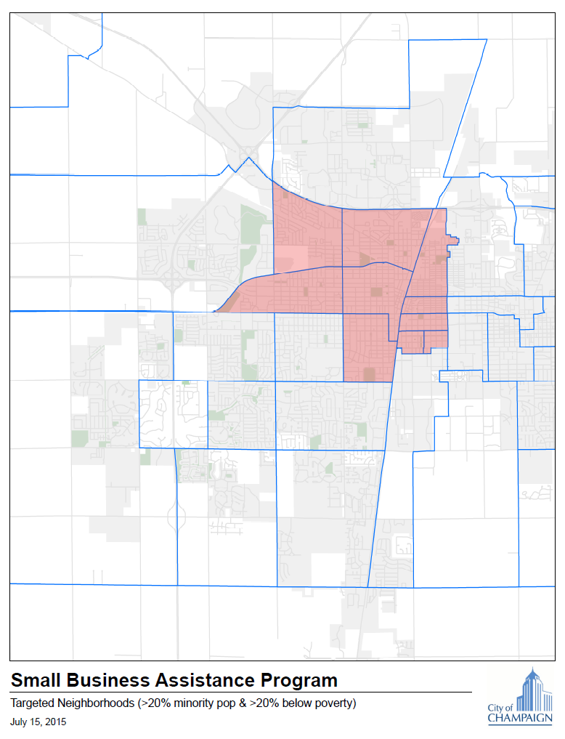
Kirby Ave
Wright St.
Prospect Ave
Springfield Avenue
Mattis Ave
I-74
I-72

Financial Assistance Worksheet
Applicants that meet the 50% income threshold as indicated on their prior year Federal Income Tax form qualify for the 75% reimbursement. Note: Applicants must provide a copy of the previous year’s federal tax return to qualify for 75% reimbursement under this category.
Family Size | Median Family Income | 50% MFI
1 person | 50,350 | 25,200
2 persons | 57,500 | 28,750
3 persons | 64,700 | 32,350
4 persons | 71,850 | 35,950
5 persons | 77,650 | 38,850
6 persons | 83,350 | 41,700
7 persons | 89,150 | 44,600
8 persons | 94,850 | 47,450

PROGRAM APPLICATION
APPLICANT
Name:
Position/ Title
Phone: |  | Email:
Business Address: |  | City: |  |  | Zip:

COMPANY INFORMATION
Company Name or Proposed Company Name:
Has your company been incorporated? | YES | NO
If incorporated, Employer Identification Number (EIN):
State in which Incorporated:

Corporate Form
Corporation | Sole Proprietorship | Limited Liability Company | Partnership

Gender
Male | Female

Race
Alaska Native | Asian | Black or African American
Native Hawaiian or Pacific Islander | White/Caucasian | Native American
Choose not to respond

Ethnicity
Hispanic | Latino | Non-Hispanic/Latino

Veteran Status
Veteran | Non-Veteran | Veteran | Service-Disabled Veteran

Do you have any current advisors or mentors?
Advisor:
Advisor:

BUSINESS TRAINING
- Starting Your Business In Illinois (required)
Other Classes, Workshops or Courses (please list)
__________________________________________________________________________________
____________________________________________________________________________________________________________________________________________________________________

BUSINESS DESCRIPTION
Please provide a brief description of your (proposed) new business (250 words or less):
____________________________________________________________________________________
________________________________________________________________________________________________________________________________________________________________________
____________________________________________________________________________________
________________________________________________________________________________________________________________________________________________________________________
____________________________________________________________________________________
____________________________________________________________________________________
Are you planning to hire additional staff within the next 6 months? | Yes |  | No
Are you planning to open your business in a targeted neighborhood? See program guidelines. Applicants must provide a proof of address to qualify for 75% reimbursement under this category. | Yes |  | No
Do you meet the income requirements for 75% funding?  See program guidelines. Applicants must provide a copy of their most recent federal tax return to qualify for 75% reimbursement under this category. | Yes |  | No

LEGAL ASSISTANCE
Do you require Legal Assistance? | Yes: |  |  | No:
Indicate which services you need (check all that apply):
- Initial Company Formation, bylaws, application for FEIN
- Stockholder agreements and certificates
- Stock option plan
- Employment Agreement
- Non-disclosure agreements
- Other (please describe): ___________________________________________________________
__________________________________________________________________________________________________________________________________________________________________
Preferred Provider
Name of Firm: |  | Contact Name:
Address: |  | Phone Number:

FINANCIAL ASSISTANCE
Do you require Financial/Bookkeeping Assistance? | Yes: |  |  | No:
Indicate which services you need (check all that apply):
- Payroll administration for all employees of the company, including management of all tax withholdings
- QuickBooks setup for the business to begin tracking all expenses and revenue
- Arrange invoicing capability and accounts receivable processing
- Set procedures for payments to vendors
- Quarterly Financial Statements for the company
- End of year financial statements
- Other (please describe): ___________________________________________________________
__________________________________________________________________________________________________________________________________________________________________
Preferred Provider
Name of Firm: |  | Contact Name:
Address: |  | Phone Number:

MARKETING ASSISTANCE
Do you require Marketing and Design Assistance? | Yes: |  |  | No:
Indicate which services you need (check all that apply):
- Initial website design and creation
- Logo design or other graphics assistance
- Company letterhead, PowerPoint template
- Writing job advertisements and assistance with job boards
- Market research
- Other (please describe):
__________________________________________________________________________________________________________________________________________________________________
Preferred Provider
Name of Firm: |  | Contact Name:
Address: |  | Phone Number:

AFFIDAVIT
I hereby declare that I have reviewed the above statements and that the information provided is true and accurate to the best of my knowledge.
I also agree to provide information about my business status to the SBDC and the City of Champaign upon request. I understand that this information will remain confidential and will be used only to report on performance of the incentive program itself, not on individual businesses.
Applicant Signature |  | Date
SBDC DIRECTOR’S APPROVAL
SBDC DIRECTOR’S APPROVAL
I hereby declare that this applicant has met the requirements of the Illinois Small Business Development Center at Champaign County EDC for admission to the City of Champaign Small Business Incentive Program.
Don Elmore, Director, IL SBDC at Champaign County EDC |  | Date

CITY USE ONLY
Application #: |  | Date Application Received:
Approved By: |  | Approval Date

For questions contact the Planning and Development Department at 217-403-8800

Business Plan Outline
The following outline includes specific requirements for Champaign’s Small Business Incentive Program but it is also a good format for other business plans. You may find that some items do not apply to your business and some areas will require more detail than others.
For incentive program applicants, pay particular attention to item 8. Your plan must include details about the services or other items you need, providers or suppliers you plan to use, and price quotes or estimated costs. Use the example that follows this outline as a format for providing a summary of your funding request. This section must also include a business case describing how incentive program funds will help your business.
I encourage you to contact me with questions as you work on this plan. I will review the plan and work with you to submit an application and business plan that meet the requirements of the program.

- Executive Summary (write it last)
  - What products or services does your business provide?
  - What distinguishes you from others with similar businesses?
  - Who are your customers and what problem are you solving for them?
  - How do you plan to use funds from the incentive program?
  - Other key points to highlight about your business
- Business Description
  - Name
  - Business Form: Sole Proprietorship, Partnership, Corporation, or Limited Liability Company
  - Retail, Service, Wholesale, Construction, Manufacturing
  - Is it an existing business or a new business?
  - When is your business open? Is it seasonal?
  - Physical description or needs: Retail store, office, online business, manufacturing facility, etc.

- Products/Services
  - Specific goods, merchandise and/or services produced and sold
  - Pricing
  - How and where are your products sold or services delivered?
- Objectives
  - What are the short- and long-term objectives for your business? (Startup, quarterly, one-year, three-year, exit plan, for example)
- Marketing/Sales Plan
  - Who are your customers and how will you find them?
  - How will promote your business?
  - Competition
  - Other relevant market data
Note: Please collect and include specific market data to support your content in this section wherever possible. Free resources such as Census Business Builder and ReferenceUSA are excellent sources of market information.

- Management/Personnel
  - How does your background/experience relate to your business?
  - Who are the key personnel, what are their duties, and are those duties clearly stated?
  - Is there a plan for training personnel for both operation and management?
  - What additional resources are available to help you and your business?
  - What are your personal needs now and in 3-5 years?
- Financials
  - Past and current financial reports if you have them (income statement, cash flow, balance sheet)
  - Revenue and expense projections for the next year showing the economic impact of the planned use of funds
- Planned Use of Funds
  - How do you plan to use incentive program funds?
    - Services and/or other items needed
    - Selected service providers or suppliers
    - Price quotes or estimates
  - How will incentive program funds directly benefit your business (increased revenue, additional jobs, achieving marketing objectives, etc.)?

City of Champaign Small Business Incentive Program Sample Funding Proposal Summary

Requested Equipment / Service | Cost of Equipment / Service
Website Development | $3,000
4 Lawn Mowers | $2,000
2 Pressure Washers | $1,000
Legal Services for Company Formation | $1,500
Logo Development | $850
Total Cost | $8,350
Requested City Reimbursement Rate | 75%
Funds Requested from SBIP | $6,262.50

City of Champaign Small Business Incentive Program Sample Capital Expense Summary

Item | Quantity | Description | Source | Unit Cost
Lawn Mowers | 4 | EGO 21 in. 56-Volt Lithium-ion Cordless Battery Self Propelled Mower with 7.5Ah Battery and Charger Included | Home Depot | $500 each
Pressure Washers | 2 | Simpson MegaShot 3,100 psi 2.5 GPM Gas Pressure Washer | Home Depot | $500 each

